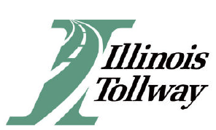
Bid Opening Results
IFB
18-0152R Non-Illinois License Plate Registration Retrieval Services
Bid Solicitation 19-557THA-PROCU-B-9466
Due Date: Friday, August 30, 2019 / Time: 10:30 Room: #219C
Vendor Name
Law Enforcement Systems, LLC (A Duncan Solutions Company)

