Consultant Rate Form (CRF) Instructions for Consultant
Frequently Asked Questions
*Revisions from previous instructions in red*

- CRF will replace all Payroll forms currently being used by the Tollway (WFRR [Work Force and Rate Revisions], PRF [Payroll Rate Form], PEPC [Project Employee Payroll Change]) for professional services invoices.
- CRF will fulfill the Certified Payroll requirement for the Tollway. Consultants may be required to submit additional information, if requested.
- CRF must be sent to Document Control (DocumentControl@getipass.com) and not to Accounts Payable as previous forms have been.
- New Contract’s initial CRF form must have an effective date of the NTP (Notice to Proceed) of the Contract.
- For current contracts with approved PEPC/PRF/WFRR: Submit a CRF only when there has been a change that affects the currently approved PEPC/PRF/WFRR on file. Consultants do not need to submit a new CRF to replace the current form on file until there is a change to the workforce for the Contract.
- Any employee with a total wage increase of 7% or greater in a running 12-month period will need to submit a detailed justification letter that will be reviewed by the Deputy Chief. Submit this letter with the updated CRF to Document Control.
*Ensure the letter includes: the employee(s) receiving the raise(s), the cumulative % increase over the running 12-month period and a detailed explanation for each employee who received a raise of over 7% in a running 12-month period.
- All Contract CRFs must be submitted a minimum of 10 days prior to submitting an invoice in order to avoid processing and payment delays.
- Contracts with a multiplier of 2.5 and 2.8 must submit a CRF for each multiplier. If two multipliers, put the multiplier that applies to the CRF in parenthesis next to the Contract Number.
- If errors are discovered, the CRF will need to be corrected before it can be routed for approval.
- The year of the PSB (Professional Services Bulletin) drives the hourly rate cap. All contracts that have a PSB year of 2017 and prior, the hourly rate cap is $70.00. Hourly rate caps established in the original contract apply.
*If your Contract is 2017 and prior and you have employees that have been previously approved for a rate above the cap, please contact Document Control.
- If your firm has more than one Tollway project running concurrently, a CRF must be submitted for each project.
- The latest version of the CRF is always available on the Tollway website. There are periodic updates, make sure you are using the most current form.
- Macros must be enabled in Microsoft Excel for the CRF to work correctly.
Only need to submit a CRF if:
- New Contract
- New Contract Employee
- Promotion of Contract Employee that results in a new classification
- Salary increase of Contract Employee is above the Max Hourly Rate listed
- Salary increase of Contract Employee is a total of 7% or greater in a running 12-month period

- Name Change of Contract Employee (for example, last name changed due to marital status)

Initial Consultant Rate Form (CRF) for New Contracts starting with CRF
- Effective date of initial CRF must be dated with the NTP date of the Contract. For Upon Request contracts, use the NTP of the overall contract, not individual Task Order NTPs.
- Enter the Year of PSB (Professional Services Bulletin).
For example, if the Contract was advertised on PSB 17-1, the year is listed as 2017. Advertised on PSB 18-1, the year is listed as 2018.
- Contract Number: Insert the DSE (Design Section Engineer) or CM (Construction Manager) Tollway Contract Number, do not insert task numbers.
- Type of Contract: Select the type of Contract of the CRF by checking one box, either DSE or CM.
- Prime Consultant Company Name: Insert the name of the Prime Consultant Company.
- Subconsultant Company Name: Insert your company name here. Prime Consultants leave this line blank.
- Last Name, First Name, Middle Initial (if applicable) are listed alphabetically by last name, Consultant Classification/Title, Original Hourly Rate at NTP or Promotion, Previous/Current Hourly Rate and Eligible for Premium Overtime columns must all be filled out. Nicknames are not to be used.
- All employees working on the project and billing on the Direct Labor Summary of the invoice must have their names and titles listed the exact same on the CRF, Direct Labor Summary, timesheets submitted, and Certified Payroll (if requested).
- Columns to be left blank on the Initial CRF: Updated Hourly Rate, Percent Increase, & Reason for Change.
- The Original Hourly Rate and Previous/Current Hourly Rate columns need to be filled out with what the employee is being currently paid at the date of NTP. These rates should match for the initial CRF. Certified Payroll may be requested to confirm if necessary. 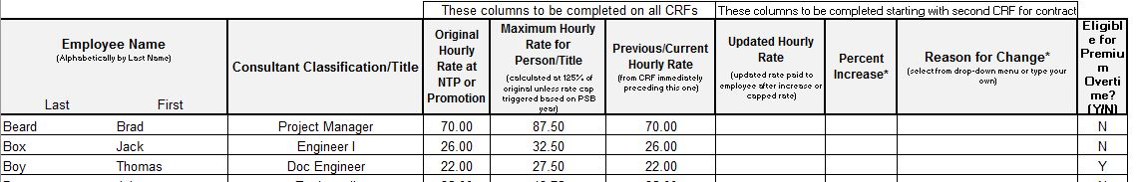
- The Maximum Hourly Rate column calculates automatically at 125% of the Original Hourly Rate at NTP. This is a locked column, do not change.
- Eligible for Premium Overtime column needs to be filled out with either YES or NO for each employee. If there was a change to which employees are eligible, a letter of justification will be required with the submittal of the CRF. A blank cell is not acceptable.
- The signature block should only appear on the last page and page numbers should be consecutive. Use the buttons at the top of the screen to add or delete rows or insert a page. Macros must be enabled.
- The Consultant Representative section at the bottom of the CRF must be filled out completely and signed. Typed signatures are not accepted. This is who will be contacted if there are any issues with the CRF and who is authorized to receive a PDF signed copy of your approved CRF. Include an email and phone number where the Consultant Representative can be reached.
- All CRFs must be submitted to Document Control (DocumentControl@getipass.com).
*To avoid delay in invoice processing and payments, ensure the CRF is submitted a minimum of 10 days prior to any invoice it will affect.*

Conversion from WFRR/PRF/PEPC to CRF
- Effective date of conversion CRF must correspond with the date the changes occurred.
For example: Jim Shoe received an increase on July 1st, the Effective Date will be listed as 7/1/2019. Jane Doe was added to the Contract on August 21st, the Effective Date will be listed as 8/21/2019.
- Enter the Year of PSB (Professional Services Bulletin).
For example, if the Contract was advertised on PSB 17-1, the year is listed as 2017. Advertised on PSB 18-1, the year is listed as 2018. The cell is RED until the year is entered.
- Contract Number: Insert the DSE (Design Section Engineer) or CM (Construction Manager) Tollway Contract Number, do not insert task numbers.
- Type of Contract: Select the type of Contract of the CRF by checking one box, either DSE or CM.
- Prime Consultant Company Name: Insert the name of the Prime Consultant Company.
- Subconsultant Company Name: Insert your company name here. Prime Consultants leave this line blank.
- The entire top of the form needs to be filled out before adding any employee names.
- Last Name, First Name, Middle Initial (if applicable) are listed alphabetically by last name, Consultant Classification/Title, Original Hourly Rate at NTP or Promotion, Previous/Current Hourly Rate, and Eligible for Premium Overtime columns must all be filled out. Nicknames are not to be used.
- Make sure all employees that will be working on the project and billing on the Direct Labor Summary of the invoice have their names and titles listed the exact same on the CRF. The name listed on the CRF, Direct Labor Summary, Timesheets submitted, and Certified Payroll must match exactly.
- When submitting the CRF form to reflect hourly rate changes and/or additions in staff, all employees presently listed on the most recently approved WFRR/PRF/PEPC to the project need to be listed, not just those individuals affected by the changes.
- Unless there is a change on an employee from the approved WFRR/PRF/PEPC on file, the following columns are to be left blank on the conversion CRF: Updated Hourly Rate, Percent Increase and Reason for Change.
- The Consultant Classification/Title column needs to list the Consultant Classification the employee was last approved to bill under. If this has changed, the employee must be listed twice documenting the change. Once with the classification that the employee was last approved to bill under, and on the next line with the employee’s new classification (and new range if they also received a pay increase).
If the employee also received a pay increase, the rate listed in the Updated Hourly Rate column will then be the rate listed in the Original Hourly Rate column for the new classification. This will give the employee a new Maximum Hourly Rate for their classification.
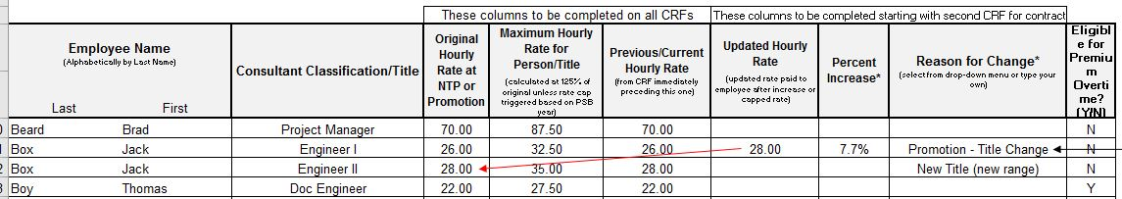
- The rate listed under the Original Hourly Rate and Previous/Current Hourly Rate columns must match for each employee and needs to be the rate from the most recently approved WFRR/PEPC.
If converting from a PRF, the rate listed in the Original Hourly Rate and Previous/Current Hourly Rate columns needs to be what the employee is currently being paid but not above the max rate range for the individual as shown on the last approved PRF. All Contracts selected from PSBs advertised in 2017 or earlier have a $70 rate cap for all employees. Certified Payroll may be requested to confirm rates if necessary.
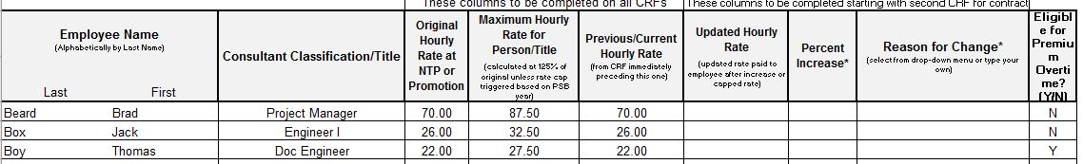
- If any employee received a raise that is listed in the Updated Hourly Rate column, there needs to be a reason listed in the Reason for Change column.
- Any raise that results in the employee’s rate being increased 7% or greater in a running 12-month period needs to be listed in the Updated Hourly Rate column. CRFs that show increases less than 7% over a running 12-month period are not required.
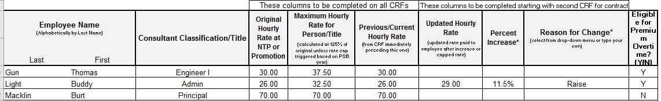
For example, if the employee receives a raise of 3% in January (which does not necessitate the submittal of a new CRF) and then receives a raise of 5% in October, a CRF would have to be submitted with the October date showing 8% increase since it was within a running 12-month period.

- If the raise given is 7% or greater or the total increase over a running 12-month period has exceeded 7%, there needs to be a letter that explains which employee received a raise, how much they received over a running 12-month period and an explanation of why the employee received the raise(s). If multiple employees received a raise 7% or greater, you may submit one letter, but all employees need to be listed and each need a detailed reason.
If an employee received a raise of over 7% during a running 12-month period and it was documented on a CRF, and the employee receives another raise of any amount during the running 12-month period following the raise, the raise needs to be documented on a CRF and a letter must be submitted explaining the multiple raises.
- The “Maximum Hourly Rate for Person/Title” column calculates automatically based off the PSB year and what is listed in the “Original Hourly Rate at NTP or Promotion.” This is a locked column, do not change.
- Anytime an employee receives a raise that puts their Current Hourly Rate over their Maximum Hourly Rate, it will require a letter of explanation why the rate for this employee has exceeded the maximum hourly rate without the employee receiving a promotion. A letter will be required each time the particular employee receives an increase above the maximum hourly rate without receiving a promotion.
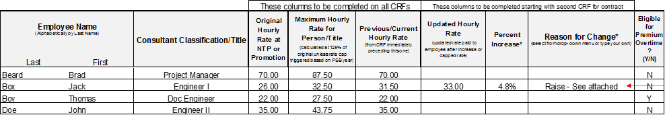
- Eligible for Premium Overtime column needs to be filled out with either YES or NO for each employee. If there was a change to which employees are eligible, a letter of justification will be required with the submittal of the CRF. A blank cell is not acceptable for any employee.
- If removing an employee, the Original Hourly Rate, Maximum Hourly Rate and Previous/Current Hourly Rate columns all need to be filled out with what the employee was last approved to bill at. In the Reason for Change Column, please list REMOVE. Then on the next CRF submittal, remove the employee entirely off the CRF.
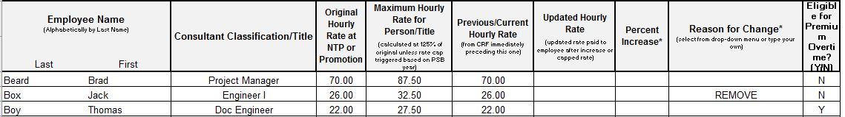
- When a name change occurs, the employee will need to be listed twice on the CRF documenting the name change. Once with the previous name and in the Reason for Change column, please list Name Change. Then list the employee again with the new name, alphabetically, and in the Reason for Change column, list Name Change (Previously ….) and list the employee’s previous last name in the parenthesis.
- The signature block should only appear on the last page and page numbers should be consecutive. Please use the buttons at the top of the screen to add or delete rows or insert a page.
- The Consultant Representative section at the bottom of the CRF must be filled out completely and signed. Typed signatures are not acceptable. This is who will be contacted if there are any issues with the CRF and who is authorized to receive a PDF signed copy of your approved CRF. Include an email and phone number where the Consultant Representative can be reached.
- All CRFs must be submitted to Document Control (DocumentControl@getipass.com).
- If converting from a PRF or Exhibit C-3, you do not need to send in a CRF if an employee received a raise that is below the range the employee fits into on the PRF or Exhibit C-3 but will need to submit for all other reasons (new employee, removed employee, new classification, raise above the classification max).
*To avoid delay in invoice processing and payments, ensure the CRF is submitted a minimum of 10 days prior to any invoice it will affect.*

Second and all future dated CRFs on the Contract
- The effective date on the submitted CRF needs to correspond with the date the change occurred.
For example: Jim Shoe received a promotion on July 1st, the Effective Date will be listed as 7/1/2019. Jane Doe was added to the Contract on August 21st, the Effective Date will be listed as 8/21/2019.
- Need to enter the Year of PSB (Professional Services Bulletin).
For example, if the Contract was advertised on PSB 17-1, the year is listed as 2017. Advertised on PSB 18-1, the year is listed as 2018. The cell is RED until the year is entered.
- Contract Number: Insert the DSE or CM Tollway Contract Number, do not insert task numbers.
- Type of Contract: Select the type of Contract of the CRF by checking one box, either DSE or CM.
- Prime Consultant Company Name: Insert the name of the Prime Consultant Company.
- Subconsultant Company Name: Insert your company name here. Prime Consultants leave this line blank.
- The entire top of the form needs to be filled out before adding any employee names.
- All employees listed on the previous CRF must be listed on the submitted CRF. Unless they were designated as “Remove from Contract” or similar on the previous CRF.
- Employee titles must be the same as the previous CRF. If this has changed, the employee must be listed twice documenting the change. Once with the classification that the employee was last approved to bill under, and on the next line with the employee’s new classification (and new range if they also received a pay increase).
If the employee also received a pay increase, the rate listed in the Updated Hourly Rate column will then be the rate listed in the Original Hourly Rate column for the new classification. This will give the employee a new Maximum Hourly Rate for their classification.
- Column “Original Hourly Rate at NTP or Promotion” needs to be the same as previous CRF. This column does not change for an employee unless they received a Promotion which gives them a new rate range (see example above). If the employee received a raise on the previous CRF, the new rate will be listed in the Previous/Current Hourly Rate and the Original Hourly Rate column will not change and still list the Original Rate. (see below)
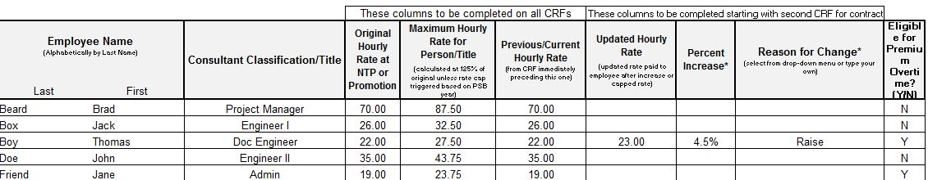
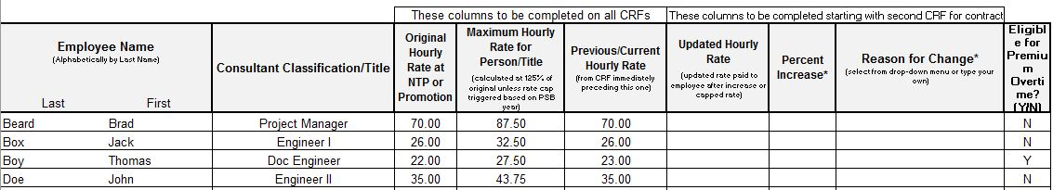
- The “Maximum Hourly Rate for Person/Title” column calculates automatically based off the PSB year and what is listed in the “Original Hourly Rate at NTP or Promotion.” This is a locked column, do not modify.
- Anytime an employee receives a raise that put’s their Current Hourly Rate over their Maximum Hourly Rate, it will require a letter of explanation why the rate for this employee has exceeded the maximum hourly rate without the employee receiving a promotion. A letter will be required each time the particular employee receives an increase without receiving a promotion.
- The “Previous/Current Hourly Rate” column needs to be filled out for all employees with the rate that was listed on the previously approved CRF. If the employee is added as New on the CRF, the rate listed in the “Original Hourly Rate” and “Previous/Current Hourly Rate” columns need to match.
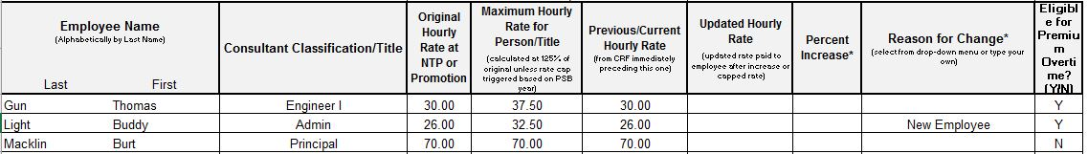
- If the rate listed in the “Previous/Current Hourly Rate” is not current from the last approved CRF, fill out the Updated Hourly Rate column with the employee’s actual hourly pay rate on the Contract. Only rate changes of 7% or greater in a 12-month period needs to be shown in Updated Hourly Rate column unless they have already received an increase of 7% or greater over the same 12-month period. Certified Payroll may be requested to confirm if necessary.
- If any employee received a raise that is listed in the Updated Hourly Rate column, there needs to be a reason listed in the Reason for Change column. Any raise that results in the employee’s rate being increased 7% or greater in a 12-month period needs to be listed in the Updated Hourly Rate column.
For example, if the employee receives a raise of 3% in January (which does not necessitate the submittal of a new CRF) and then receives a raise of 5% in October, a CRF would have to be submitted with the October date showing 8% increase since it was within a 12-month period.
- If the Updated Hourly Rate column is different from the Previous/Current Hourly Rate, there needs to be a percentage listed in the Percent Increase column. This will be a locked column that is calculated automatically, please do not modify.
Percent Change = Updated Hourly Rate – Previous/Current Hourly Rate
Previous/Current Hourly Rate
- If any employee has a raise listed on the CRF, there needs to be a reason listed in the Reason for Change column. If the raise given is 7% or greater or the total increase over a 12-month period has exceeded 7%, there needs to be a letter that explains which employee received a raise, how much they received over a 12-month period and an explanation of why the employee received the raise. If multiple employees received a raise 7% or greater, you may submit one letter, but all employees need to be listed and each need a detailed reason.
If an employee received a raise of over 7% during a 12-month period and it was documented on a CRF, and then the employee receives another raise of any amount during the 12-month period following the raise, it will need to be documented on a CRF and a letter must be submitted explaining the raises.
- Eligible for Premium Overtime needs to be filled out with either YES or NO for each employee. If there was a change to which employees are eligible, a letter of justification will be required with the submittal of the CRF. This cannot be left blank for any employee.
- If removing an employee, the Original Hourly Rate, Maximum Hourly Rate and Previous/Current Hourly Rate columns all need to be filled out with what the employee was last approved to bill at. In the Reason for Change Column, please list REMOVE. Then on the next CRF submittal, remove the employee entirely off the CRF.
- When a name change occurs, the employee will need to be listed twice on the CRF documenting the name change. Once with the previous name and in the Reason for Change column, please list Name Change. Then list the employee again with the new name, alphabetically, and in the Reason for Change column, list Name Change (Previously ….) and list the employee’s previous last name in the parenthesis.
- The signature block should only appear on the last page and page numbers should be consecutive. Please use the buttons at the top of the screen to add or delete rows or insert a page.
- The Consultant Representative section at the bottom of the CRF must be filled out completely and signed. Typed signatures are not accepted. This is who will be contacted if there are any issues with the CRF and who is authorized to receive a PDF signed copy of your approved CRF. Include an email and phone number where the Consultant Representative can be reached.
- When submitting a CRF form to reflect hourly rate changes and/or additions in staff, all employees presently assigned to the project need to be listed, not just those individuals affected by the changes.
- All CRFs must be submitted to Document Control (DocumentControl@getipass.com).

*To avoid delay in invoice processing and payments, ensure the CRF is submitted a minimum of 10 days prior to any invoice it will affect.*

Acronyms

CRF: Consultant Rate Form
PEPC: Project Employee Payroll Change - form
PRF: Payroll Rate Form
WFRR: Work Force Rate Revision
PSB: Professional Services Bulletin
DSE: Design Section Engineer
CM: Construction Manager
CS: Contract Services

Revised CRF Procedure

If a CRF has already been approved and there was a mistake (rate was listed incorrectly, a raise was not reported, name spelled wrong, promotion was not reported) you may need to submit a Revised CRF to correct the issue.

- The Revised CRF will ONLY have the employee listed that the issues concern (do not list all employees) and will list the correct information along with a reason in the Reason for Change column.
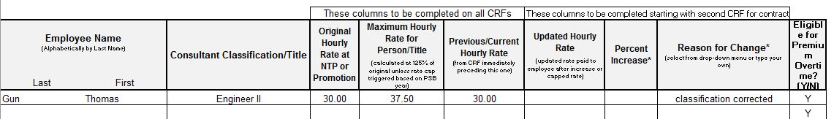

- The Effective Date listed on the Revised CRF will be the same date from the CRF that the issue was found but will have REV typed after the date.

